As of Week 9. I have finished coding the structure for the following components:  
(1) intro page

(2) What is diabetes (topic introduction)

(5) main jumping game + game end

Less finished components include

(3) explore hidden sugars page - it should include a slider somewhere once done

(4) what are the other ways to mitigate Type II diabetes - will be a flipcard explore page

Note: N.C under week = new concept used

| Week | Concept | How I’ve used it | Lines | Filename |
| --- | --- | --- | --- | --- |
| 1 | Going into different folder | Use of “../” in linking the different index.html as they are in different folders | - | In all index.html file buttons |
| 2 | Using Tags | Using tags to determine the placement of objects and the game instructions | 11-16 | 5jumping game>index.html |
| 3 | Conditionals and functions | Used in score checking and in the main game loop.  - Checks score and asks player to replay if score is less than 200  - Otherwise, player can proceed to the end  - Used in main game loop to determine if pancreas has hit the sugar  - Also to make the sugar disappear after the pancreas has jumped past it | 24-33, 48-56 | 5jumping game>script.js |
| 3 | Variables | Used to declare the pancreas, rock and score |  | 5jumping game>script.js |
| 4 | DOM object model | Used to get the different variables which are controlled | 2-4 | 5jumping game>script.js |
| 5 | AddEventListener | Allow the user to press the spacebar and cause the pancreas to jump | 16-18 | 5jumping game>script.js |
| 6 | Arrays | Use of arrays to insert data of male and female crude rate of diabetes + years | 1,8, 15 | 2explorediabetes>appscript>main.js |
| 7 | Chart making |  |  |  |
| - | classList | Adding the jump animation to the pancreas to make it jump (learnt in grasshopper) | 9, 12 | jumping game>script.js |
| N.C | parseInt | Use of parseInt function to string an integer. This is to find the position of each element (sugar and the pancreas) to find out where they are and if the pancreas has hit the sugar |  |  |
| N.C | keyframes | @keyframes sugar {  0%{left: 500px;}  100%{left :-50px;}  }  Using keyframes to make the sugar move from one side of the game screen to the other (making it appear that the pancreas is moving forward)  @keyframes jump{  0%{top:200px;}  50%{top:50px;}  75%{top:50px;}  100%{top:200px;}  }  Keyframes also used to make the pancreas appear to be jumping. The 50 and 75% of the jump is the same to make it appear that the pancreas holds a while in midair to jump over the sugar stack | 63-65,  73-77 | jumping game>appstyle.css |

Some errors I faced along the way: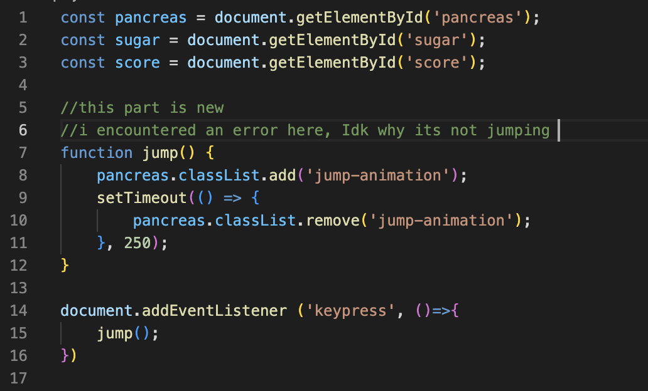

I eventually realized the reason was in line 15, i was not calling the jump function. This is how I resolved it:

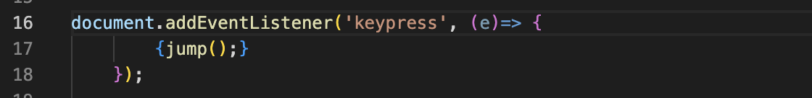

Other current errors I am facing:

Explore sugar page button should change the background image of the “food” item.. However it is currently not changing.

**Potential future developments:**- levels to the current jumping game